Lab #06:

CLIENT-SIDE SCRIPTING (JSON)
Topic | Web page development using JSON
Learning objective | Students will be able to retrieve, parse, and display JSON data, applying fundamental client-side scripting techniques to dynamically update web content.
Lab activity objective | Students will demonstrate their ability to load JSON data, extract specific data points in creating an interactive and user-friendly web experience.

Instruction: Answer all questions. Write your answer and screenshot the output in Microsoft Word.
Submit through Author in zip format.
- Consider the following collection of books:
 | Book 1 | Book 2
title | The Great Gatsby | To Kill a Mockingbird
author | F. Scott Fitzgerald | Harper Lee
publicationYear | 1925 | 1960
genres | Fiction, Classics | Fiction, Coming-of-Age

Create a JSON representation (.json file) of this collection. You may refer to the given JSON sample file (students.json) as a reference.

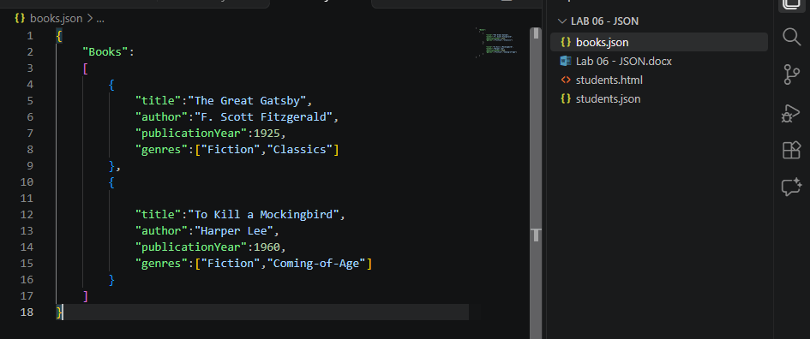

- Based on the JSON you have written in Question (1), write an HTML file to display the following details.

- The title of the first book.
- The author of the second book.
- The genres of all books.
You can display the details through Inspect – Console on your browser. You may refer to the given sample HTML file (students.html) as a reference.
